Carbonate dissolution in RADI
RADI uses time steps of 4 minutes to resolve processes. Logic of calculating carbonate chemistry is:
1. Current DIC/TA/Ca are used to calculate dCO₃²⁻
2. Current dCO₃²⁻and Ca determine Ω
3. Ω determines dissolution/precipitation
4. Dissolution/precipitation contribute to dDIC/dt, dTA/dt, dCa/dt
5. The state is updated with rates of change including all other processes
6. New pH/dCO3 are recalculated at the next solver call

Specifically:
Uses 2 polymorphs of CaCO₃, low Mg calcite and aragonite with different dissolution kinetics depending on their saturation state (resp. Ω_{ca, z} and Ω_{arag, z}).
These depth dependent saturation states of seawater with respect to calcite or aragonite are computed as:
$Ω_{z}= \frac{{[{Ca}^{2+}]}_{z}.[{{CO}_{3}^{2-}]}_{z}}{K_{sp}^{*}}$,
with $K_{sp}^{*}$ the stoichiometric solubility constant of calcite or aragonite at in situ pressure, temperature and salinity (following Mucci 1983 and Mollero 1995).
This uses ${[{Ca}^{2+}]}_{z}$ and $[{{CO}_{3}^{2-}]}_{z}$ from the previous step (t-1). Specifically, $[{{CO}_{3}^{2-}]}_{z}$ is calculated by first computing the total hydrogen ion [H⁺] concentration from Talk and DIC:
${[H^{+}]}_{t}={[H^{+}]}_{t-1}-\frac{[TAlk]({\left[H^{+}\right]}_{t-1}, \left[\sum{{CO}_{2}]}\right)-[TAlk]}{d[TAlk]({\left[H^{+}\right]}_{t-1}, \left[\sum{{CO}_{2}]}\right)/d{\left[H^{+}\right]}_{t-1}}$
Once $[H^{+}]$ is known, the carbonate concentration is computed as follows:
$$\left[{CO}_{3}^{2-}\right]= \frac{[\sum{{CO}_{2}]}. K_{1}^{*}.K_{2}^{*}}{K_{1}^{*}.K_{2}^{*}+K_{1}^{*}.{\left[H^{+}\right]}_{t}+{\left[H^{+}\right]}_{t}^{2}}$$
(get $[H^{+}]$ and $\left[{CO}_{3}^{2-}\right]$ from seacarb in R (carb()))
Then dissolution rates and precipitation rates are all calculated, representing a continuum:
$$R_{\left\{diss, ca, z\right\}}= \left[Calcite\right]* k_{\left\{diss, ca\right\}}* {\left(1 - Ω_{\left\{ca\right\}}\right)}^{η_{\left\{diss, ca\right\}}}$$
$$R_{\left\{diss, arag, z\right\}}= \left[Aragonite\right]* k_{\left\{diss, arag\right\}}* {\left(1 - Ω_{\left\{arag\right\}}\right)}^{η_{\left\{diss, arag\right\}}}$$
$$R_{\left\{prec, ca, z\right\}}= k_{\left\{prec, ca\right\}}* {\left(Ω_{\left\{ca\right\}}-1\right)}^{η_{\left\{prec, ca\right\}}}$$
$η_{diss}$ and $η_{prec}$are mineral specific reactionless constants, accounting for each mineral’s specific surface area, regulating reaction behaviour along the range of the saturation state $Ω$. In the paper these are optimized for the specific setting, I’m not sure how much we need / can do that for different fjord sediments.

Reactions are then implemented as:
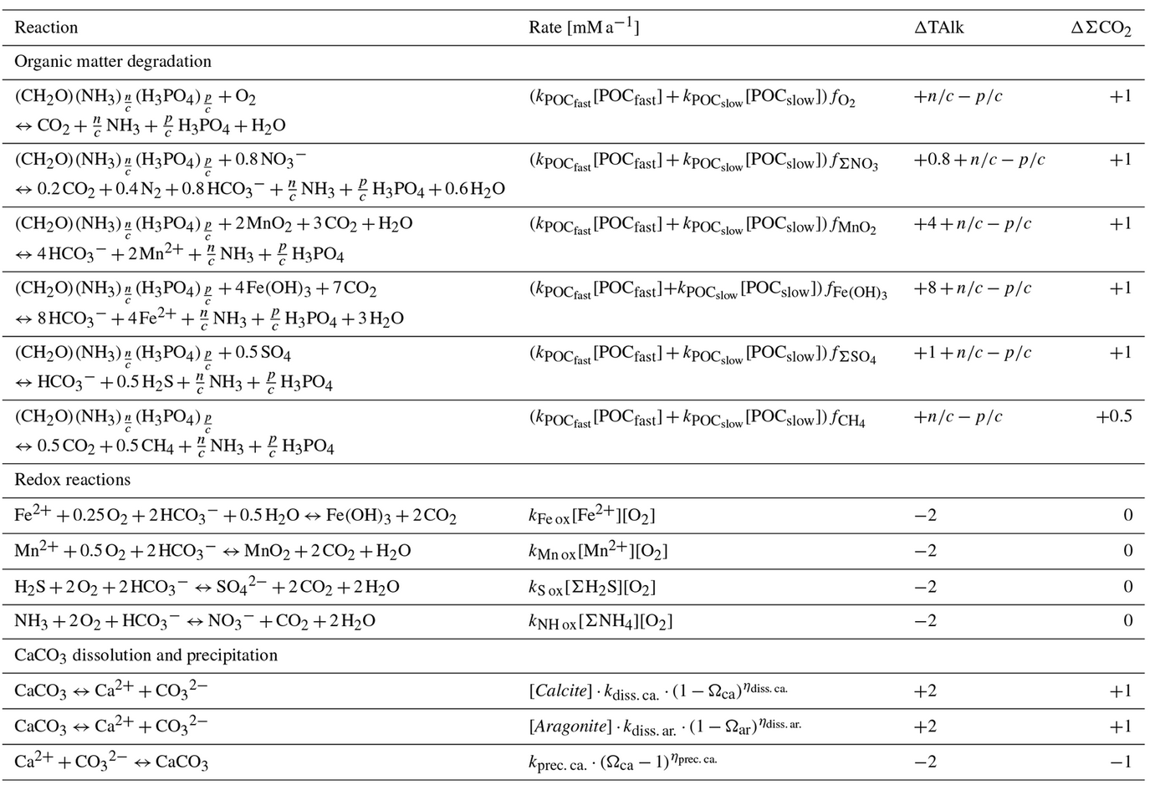
RADI state variables:
